**Aws recording Session (Edyoda )---🡺**

**Cloud computing🡪**

Cloud computing is on demand delivery of compute power, database storage applications and other IT resources through a cloud services platform via internet with pay as you for pricing.

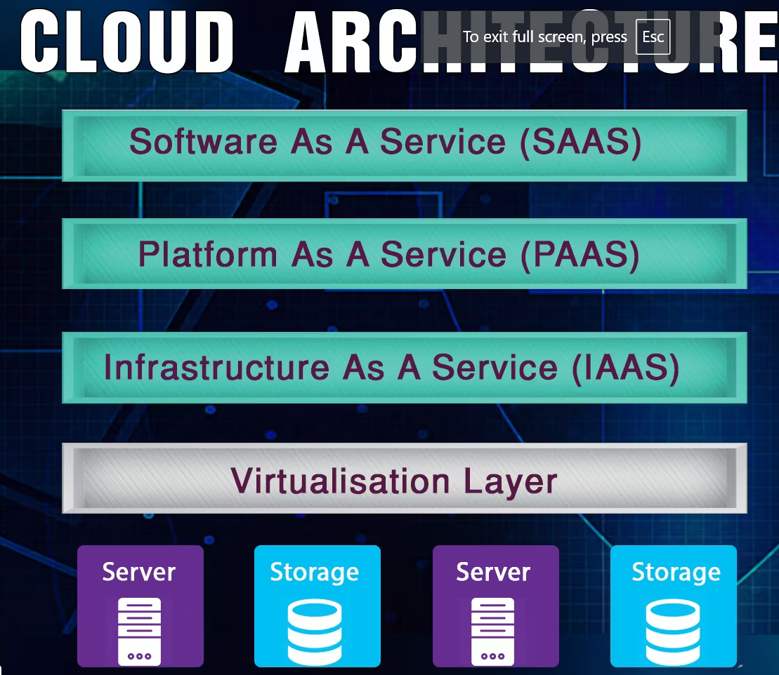

Ex.

**SAAS** 🡪 ex. Gmail, UTUBE

**PAAS** 🡪deployed database, CRM, salesforce and more

**IAAS** 🡪

**AWS cloud Data centers/ provider all over the Globe**🡪(pick nearest cloud service provider)

In India🡪 **Mumbai** and Hyderabad

For better performance, should select Mumbai region

**Virtualization layer** 🡪provide resource management, security layer

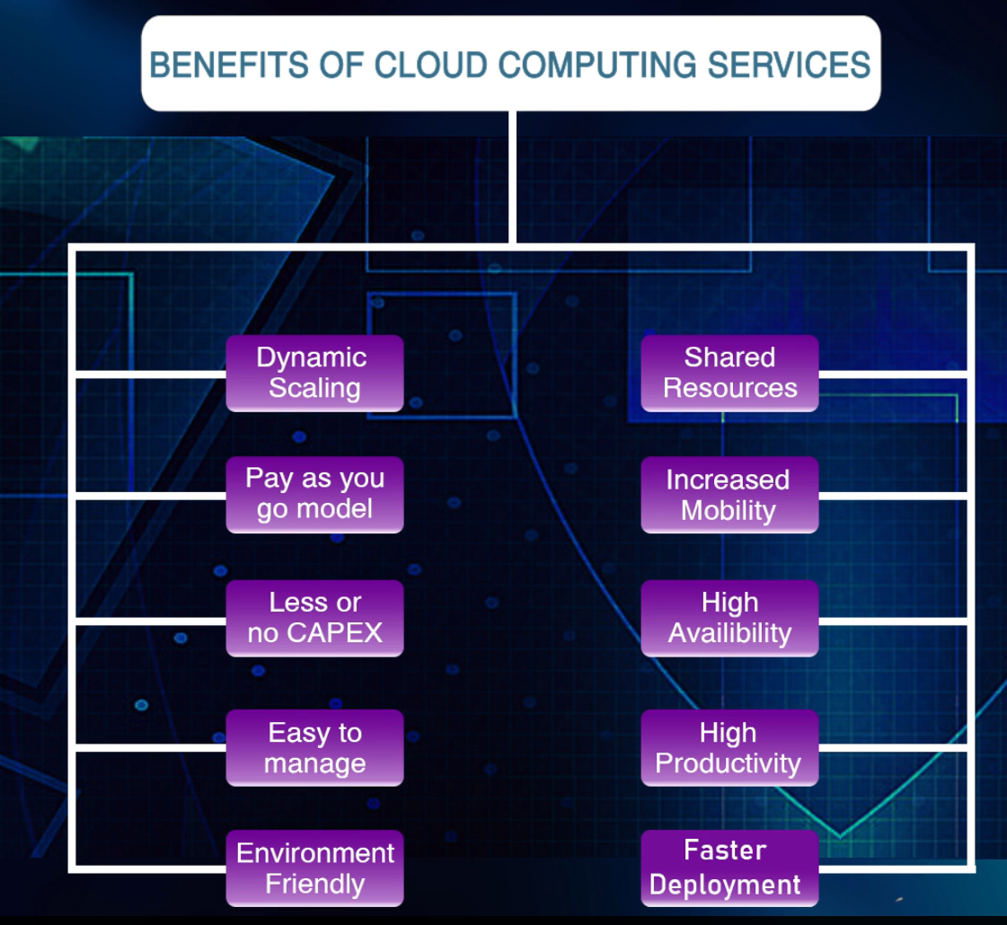

**Introduction of AWS🡪**

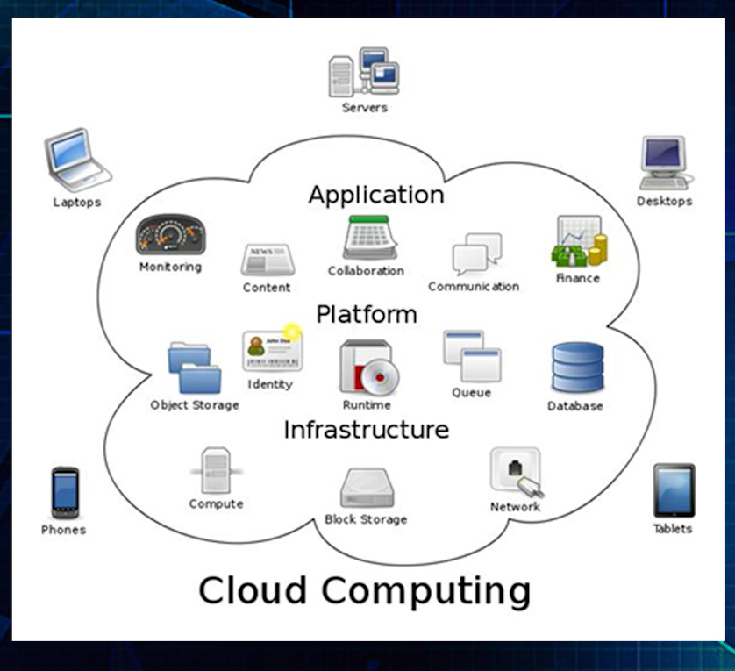

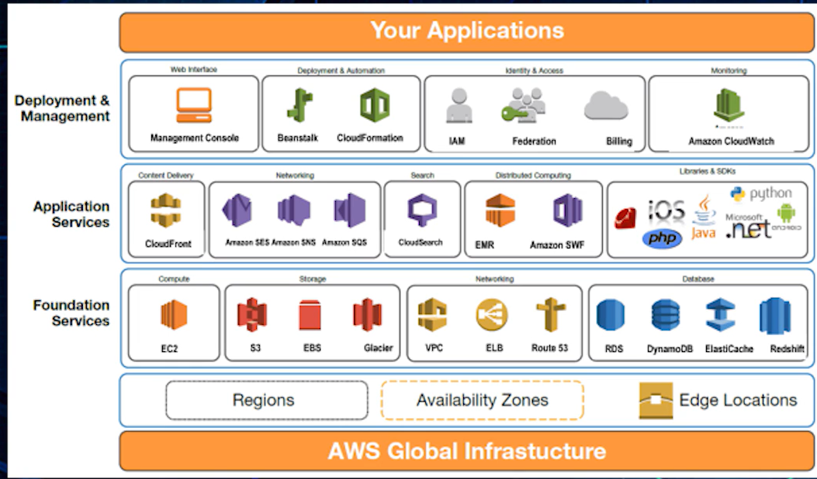

AWS Core Services🡺

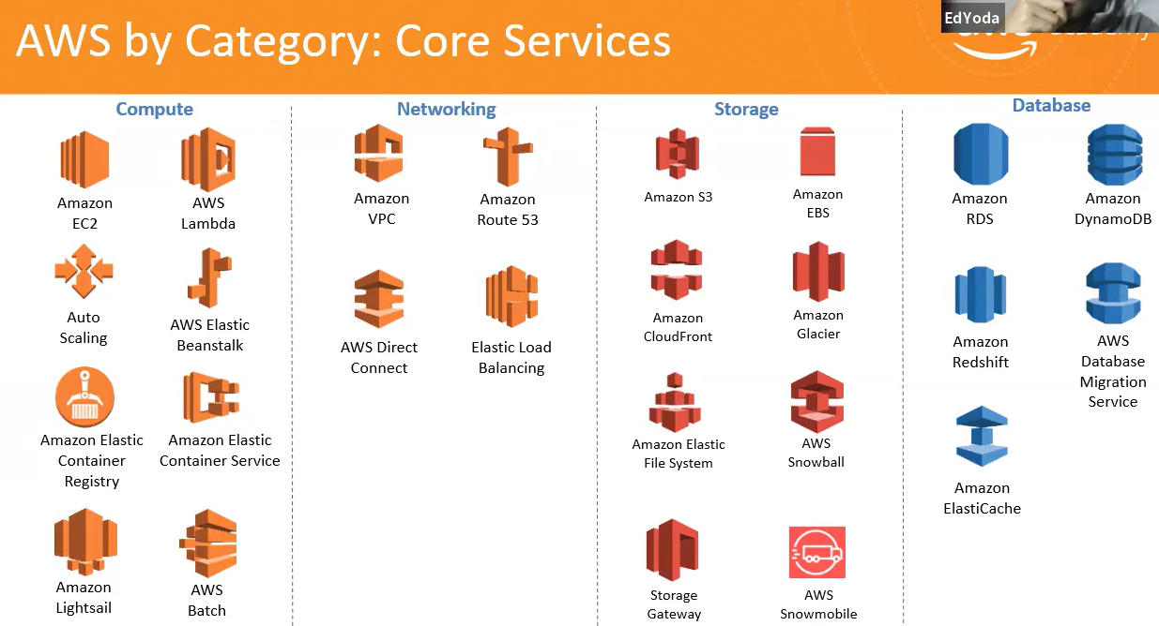

**How to create free tier account🡪**

Find out free services🡪 <https://aws.amazon.com/free>

Step1: open <https://aws.amazon.com>

Step2: Enter all detail required details

Step3: Select basic free plan

Step4: sign in to the console

Step5: Select Mumbai region

**AWS Global Infrastructure**=🡺

**Region and availability zone**🡪multiple zones worldwide. Each zone is isolated but availability zones a region are connected through **Low Latency Links.**

**Mumbai has 2 availability zones.**

**#Edge Location and Edge Cache:**

Amazon cloud front employs a global network of edge locations.

**AWS DATA Services**🡺

1. S3
2. EFS
3. Glaciers
4. Storage Gateway

**S3 instance🡪( Simple Storage Services)-collect, storage and analyze in any amount anywhere.**

S3 Basics

1. S3 is safe place to store files
2. Its object-based storage
3. This data spread across multiple devices & facilities
4. S3 is object based i.e. allow you upload files
5. File size can be from 0 Byte to 5 TB
6. There is unlimited storage
7. Files are stores in buckets
8. S3 bucket should have universal name that must be unique globally

Ex. https://s3-eu-west-1.amazonaws.com/ashishpandeyfirstbucket

9. when you upload files -HTTP 200 OK status

10. S3 provide -developer & IT Team secure, durable, high-scalable object storage

11. amazon S3 is easy to use with a simple web service interface to store & retrieve any amount of data from anywhere on the web.

**S3 Features:**

1.Durability & availability

2.Tiered Storage Available

3.Lifecycle Management

4.Versioning,

5.Encryption

6.Secure your data using access-control List & bucket policies

**Account >> Bucket >> Object >> PUT operation**

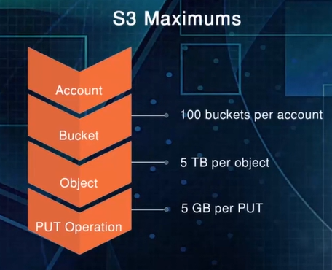

**# AWS Glacier, also known as S3 it provides Low-cost cold storage for long term. It provides storage for data archiving & backup of cold data.**

**#S3 use AWS Lambda, Redshift platform.**

**IAM User (Identity and Access Management)-🡺**

IAM provides access management for users under different roles. Another user can use services with restricted scope with temporary security credentials to perform actions that roles allow.

Step1: Security, Identity, & Compliance>> IAM

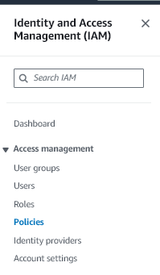

Step2: **Create role**🡪 click on Create role

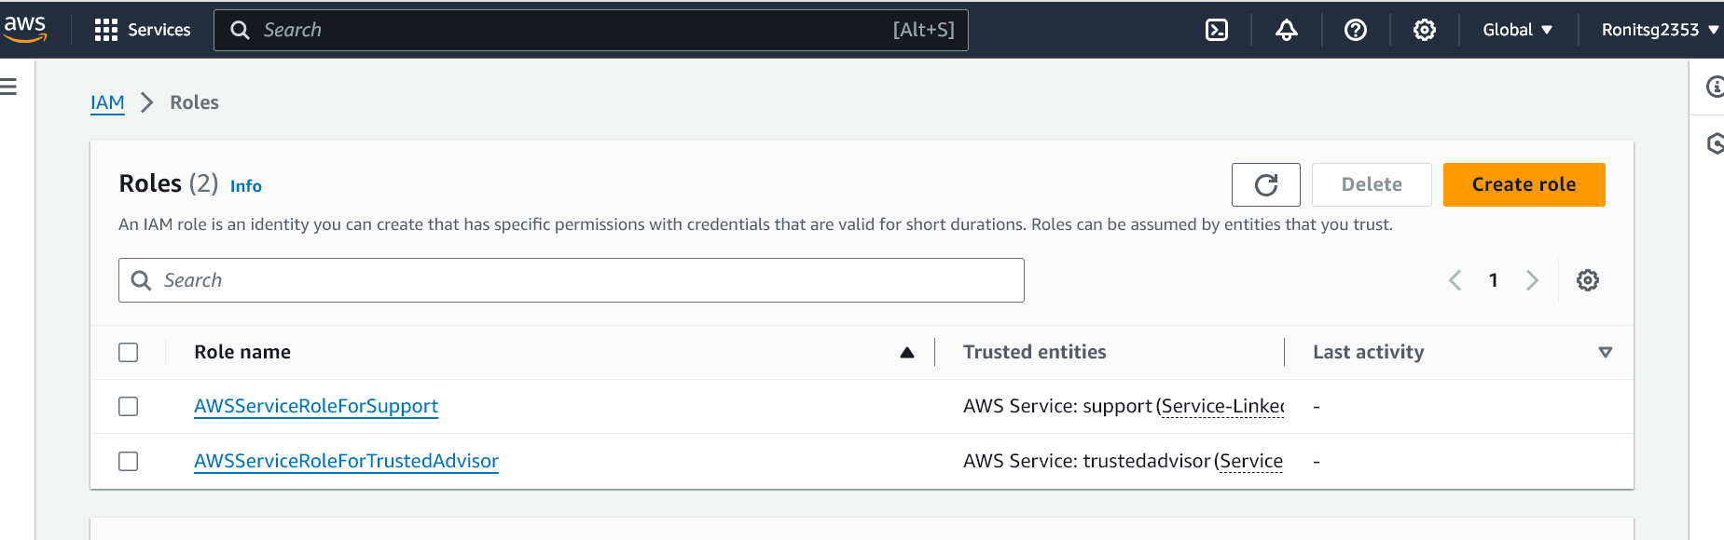

Step3**: select trusted entity**🡪AWS Service (default)

Step4: **Use Case**🡪select the Service where want to add IAM(ex.EC2 / S3)

And click on Next button

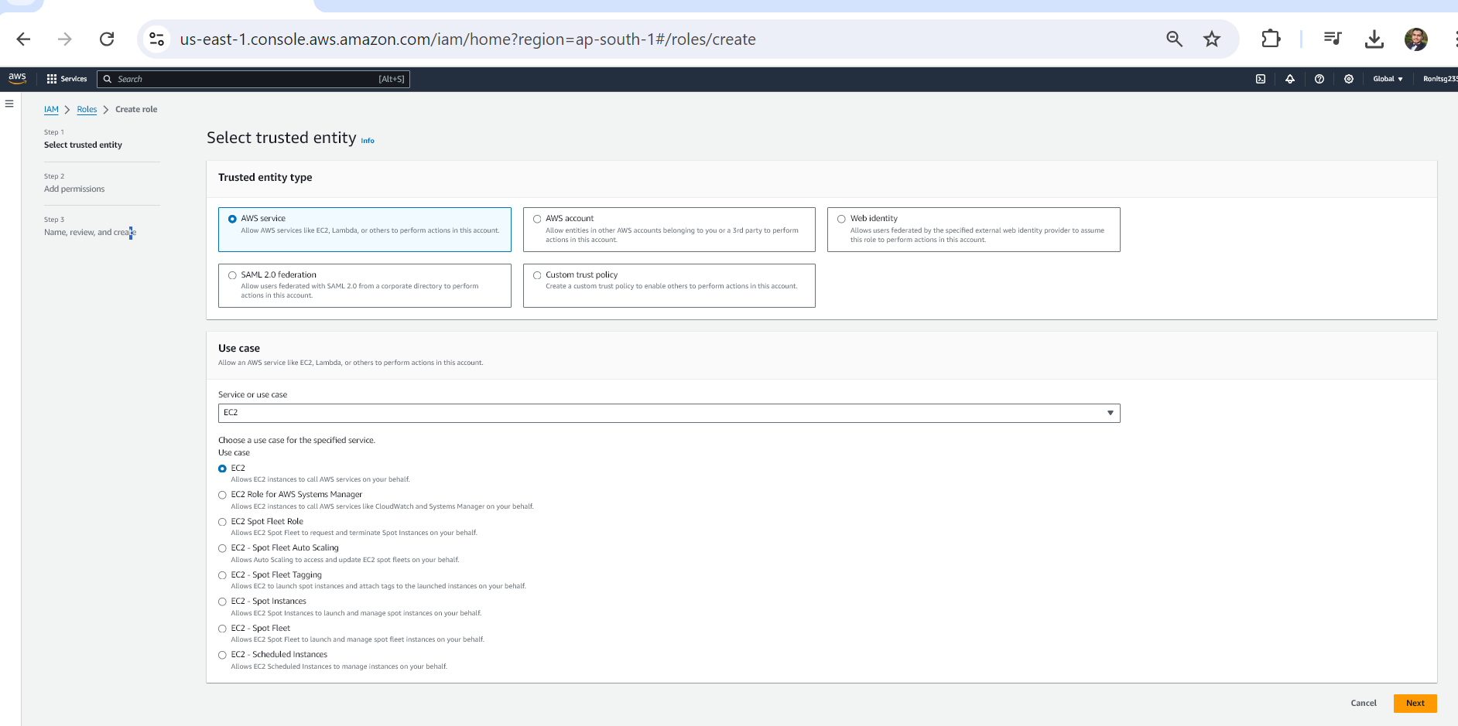

**Step5: Create Policy**🡪 u must select or add permission for access

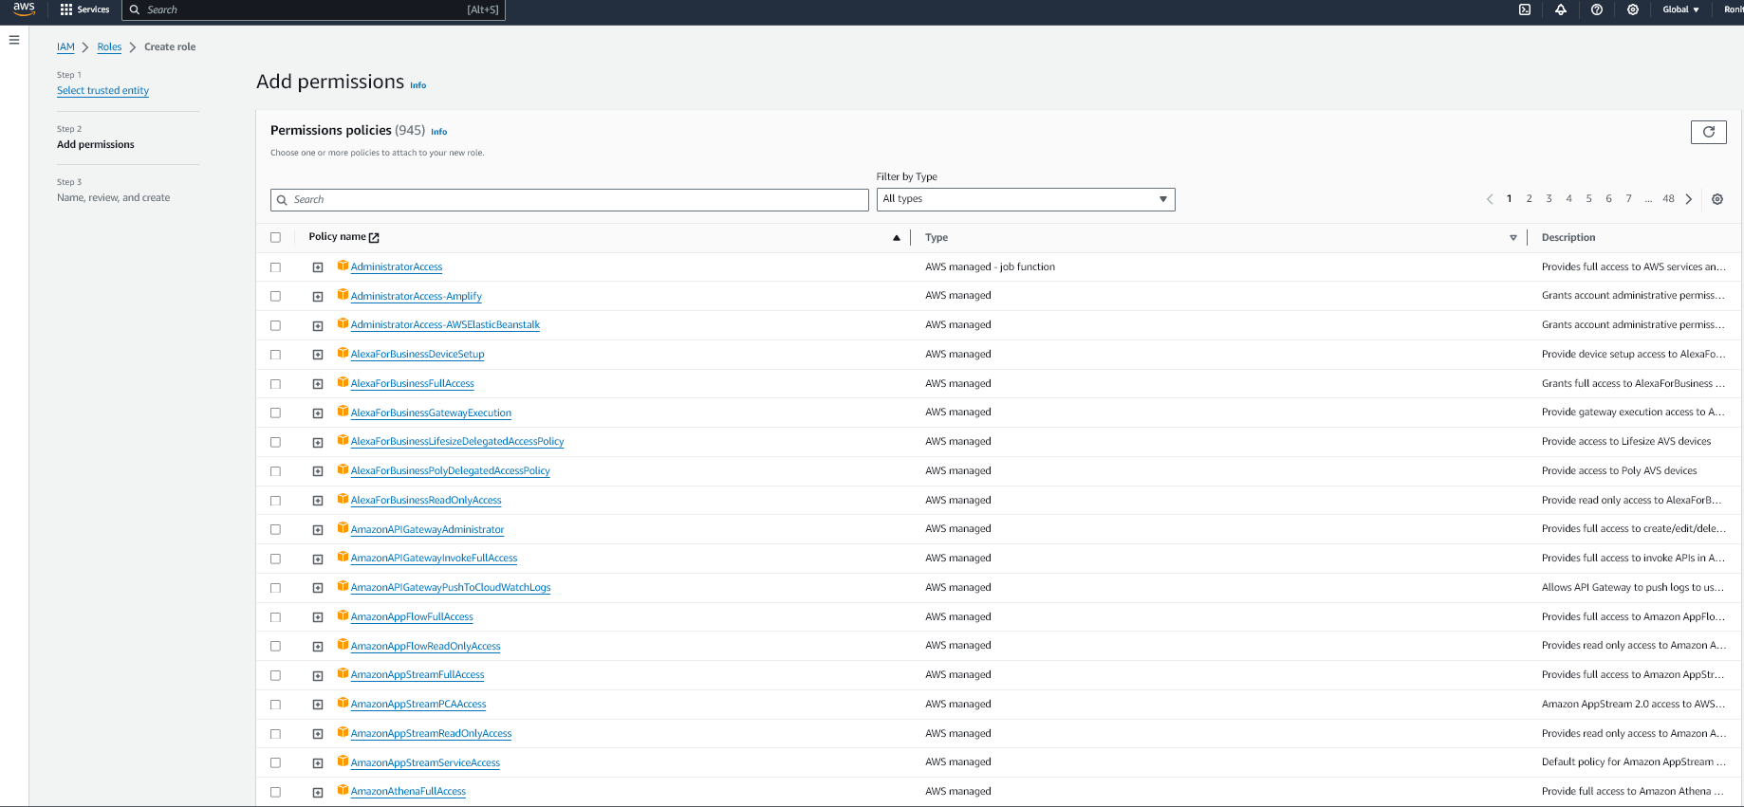

**Step: Ex. Selected Administrator Access** and click on Next

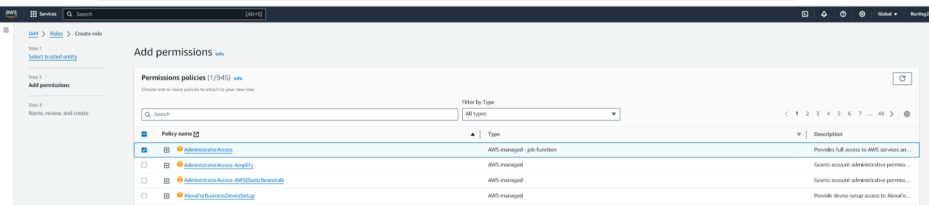

**Step: Create Policy🡪** user can create own policies🡪

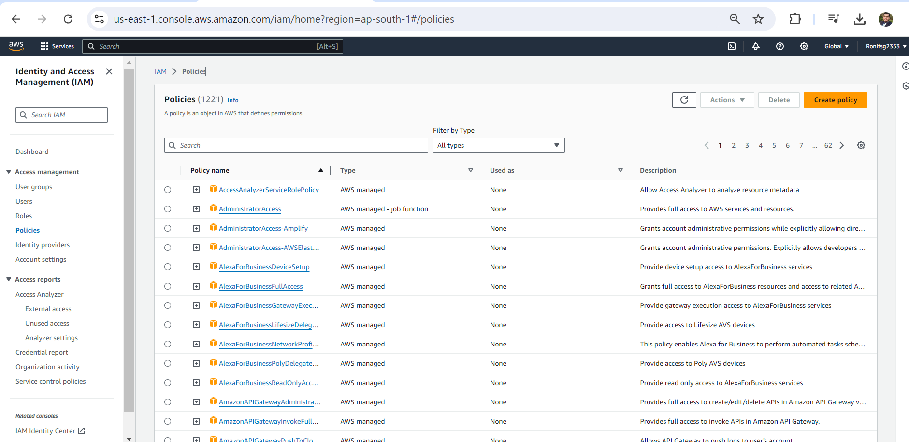

And specify the at least one Actions

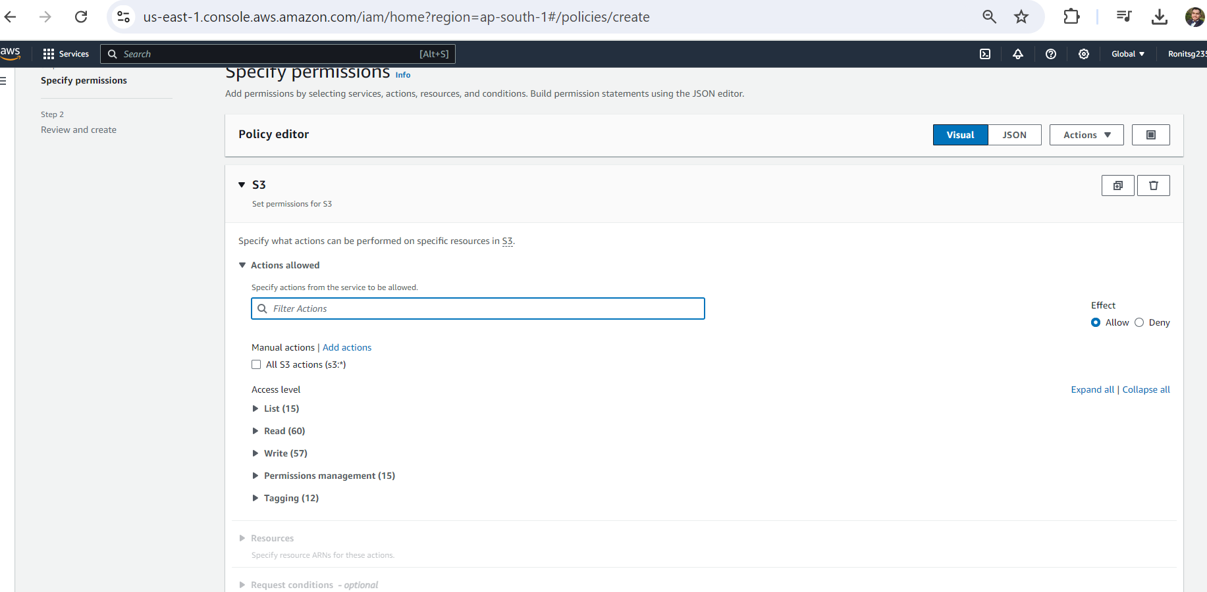

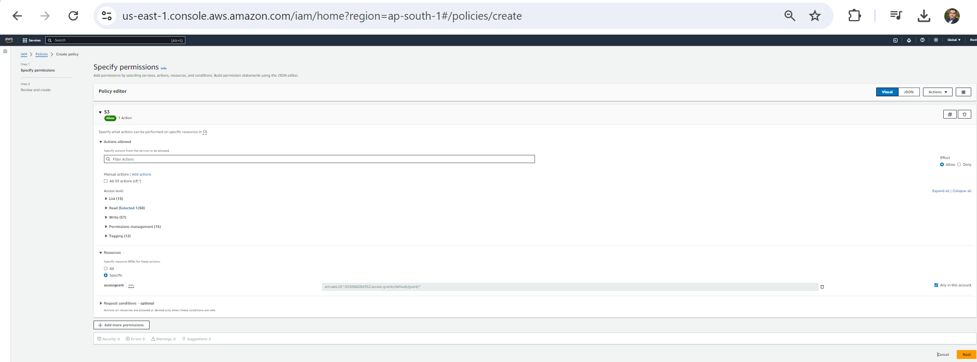

**Step: Enter name of policy 🡪**

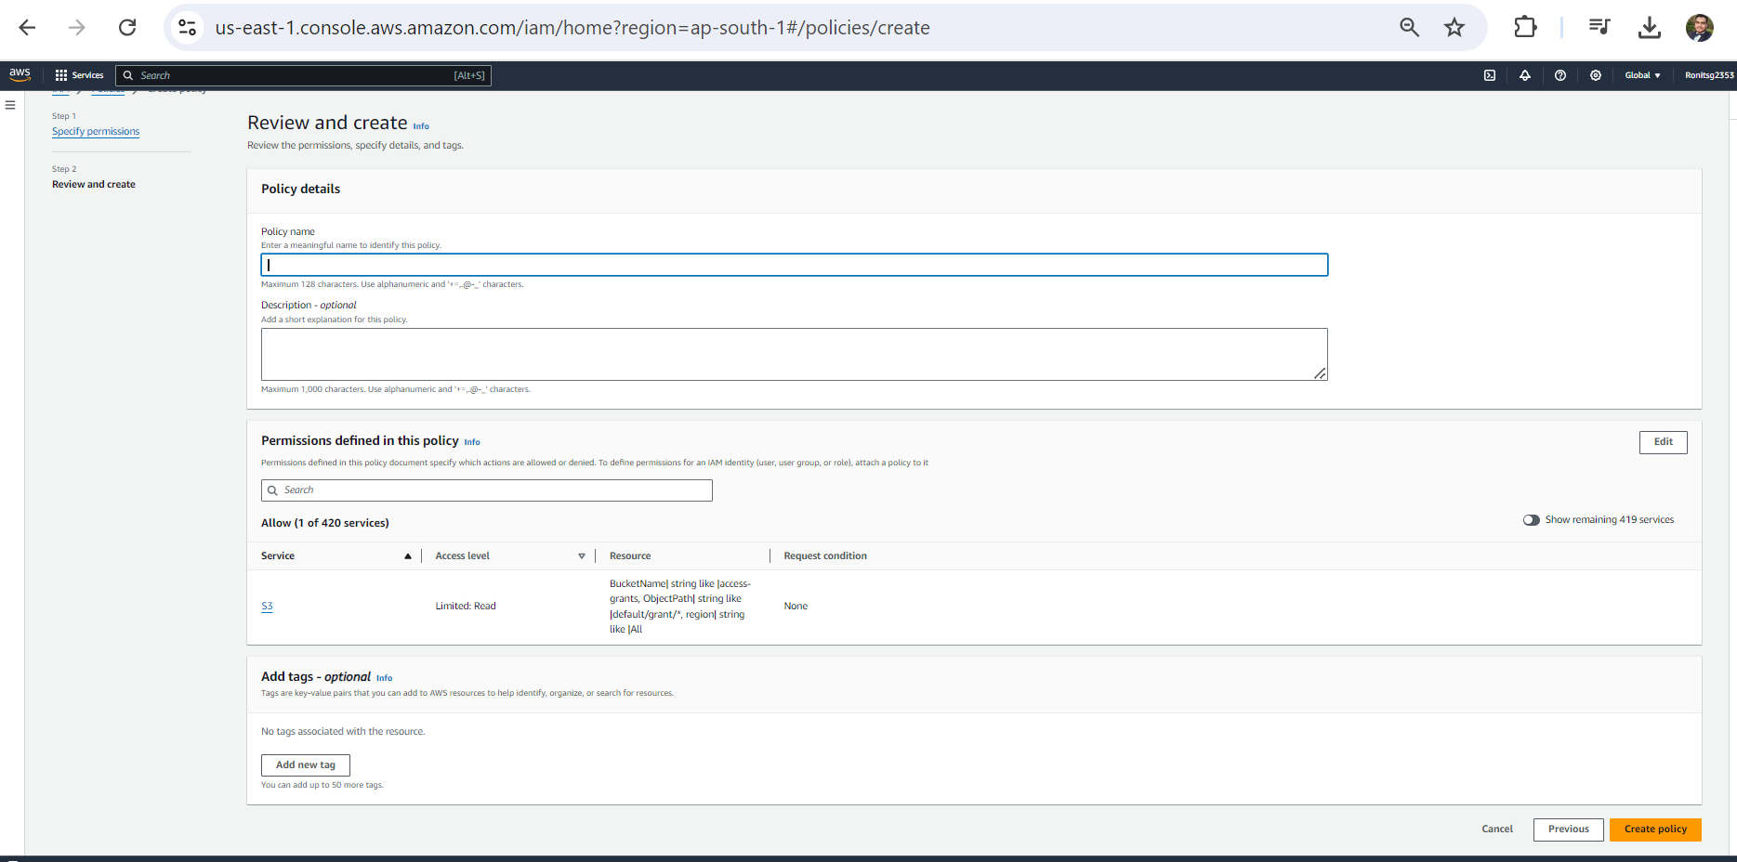

**EC2 Instance (Elastic Cloud Compute)==🡺**

**Services>> Compute>>EC2**

Ex. virtual machine, server etc.

**CloudWatch alarm-🡪monitoring service provided by AWS**

1.EC2 provides Pay as you go

2.Elastic cloud computing provide resizable compute capacity in cloud

3.Virtual machine in cloud

**E2 instance Payment options:**

1**.on Demand**:

Pay a fixed rate by hour with no commitment. Best for short term projects, spiky workload and ideal for startup.

**2.Reserved**:

Long term use 1 year or 3-year term and cheaper for long term.

**3.Spot:**

Bid for instance. Highest bidder only gets the service

**Dedicated Instance**🡪hardware dedicated to single user

**Dedicated Host**🡪server bound license-regulatory requirement. On demand pricing and cheap reserved.

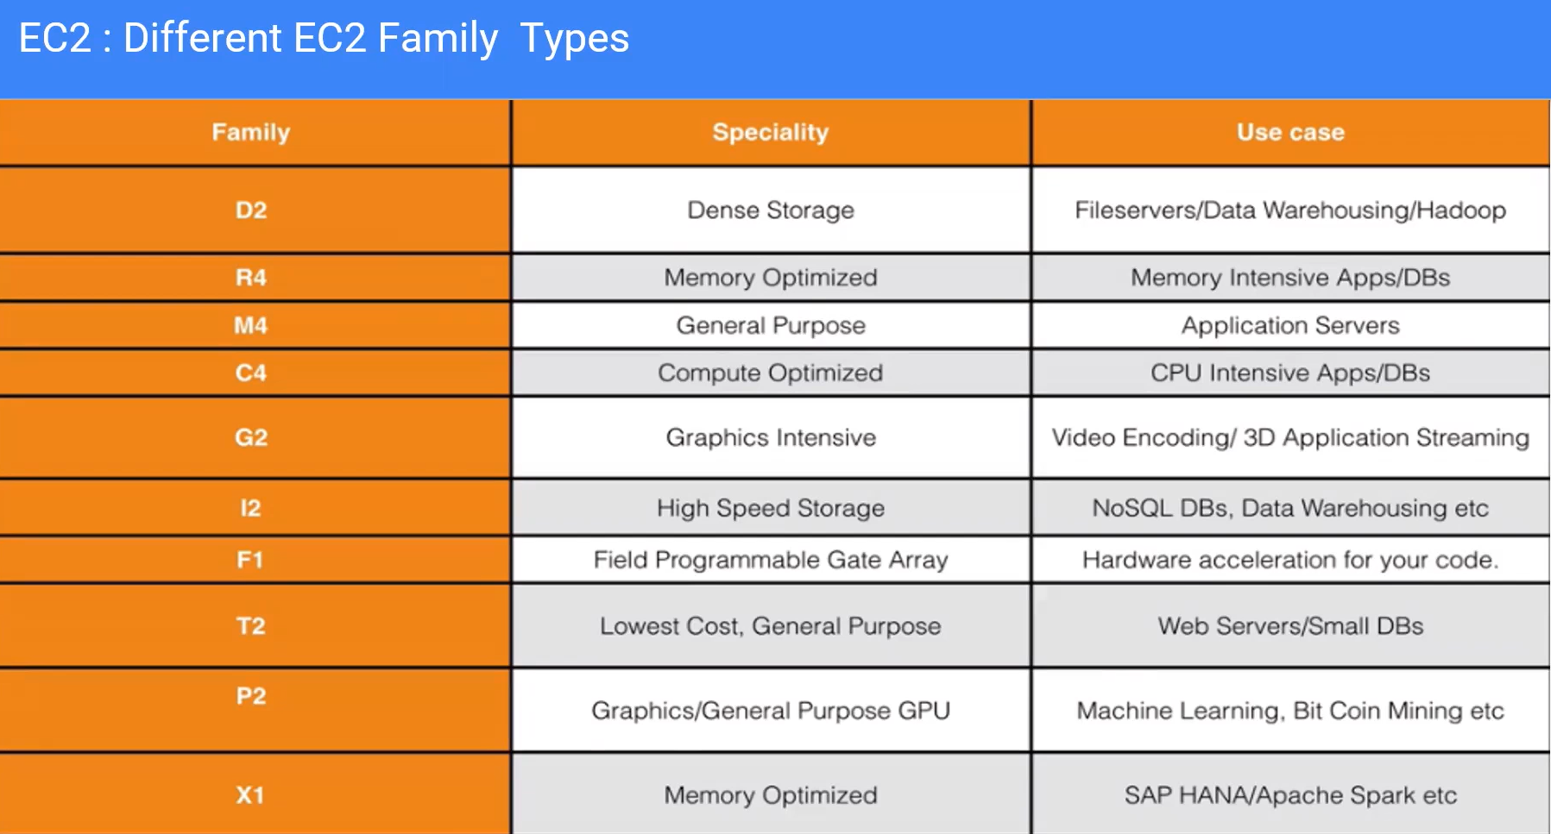

**EC2 Instance Types:**

1.General Purpose -🡪 M4,M7g

2.Compute Optimized

3.Memory Optimized

4.Accelerated Computing

5.Storage Optimized

6.HPC Optimized

We can create, modify the services 🡪

1.Command Line (CLI tool)

2.API

3.cloud formation Template

**AWS SDK** -🡪developer can create, modify the services -🡪 **Create the Queue**

Use Templates:🡪

**Management &Governance tools >> CloudFormation>> Create Stack**

**AWS Data management Services🡪**amazon service provides separate database to user there no need to connect sperate database inside EC2 .

**DynamoDB**🡪 is NoSQL Database provided by AWS.

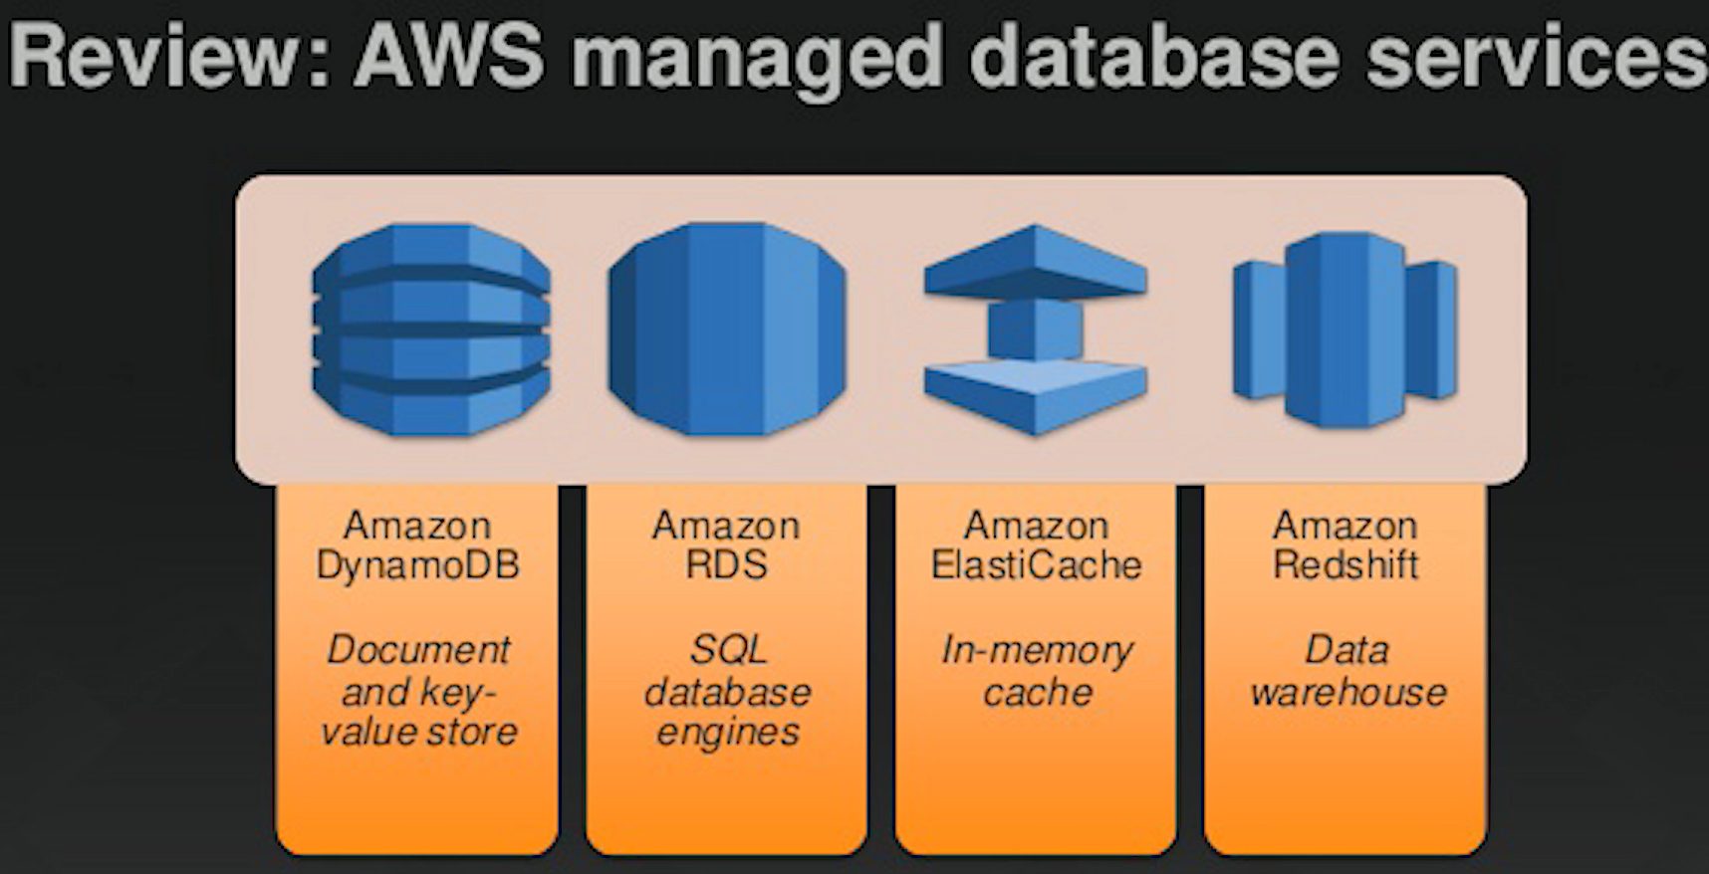

**RDS (Relational Database-comes under platform as Service)🡪**

**ex. SQL, oracle, MySQL**

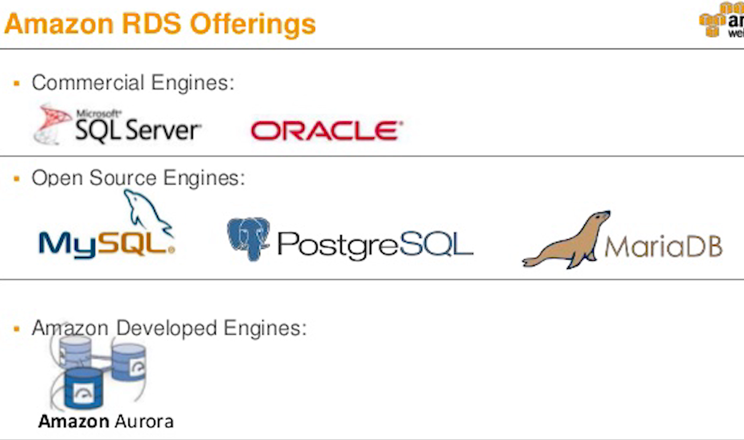

**Amazon Aurora🡺 MySQL & PostgreSQL compatible.**

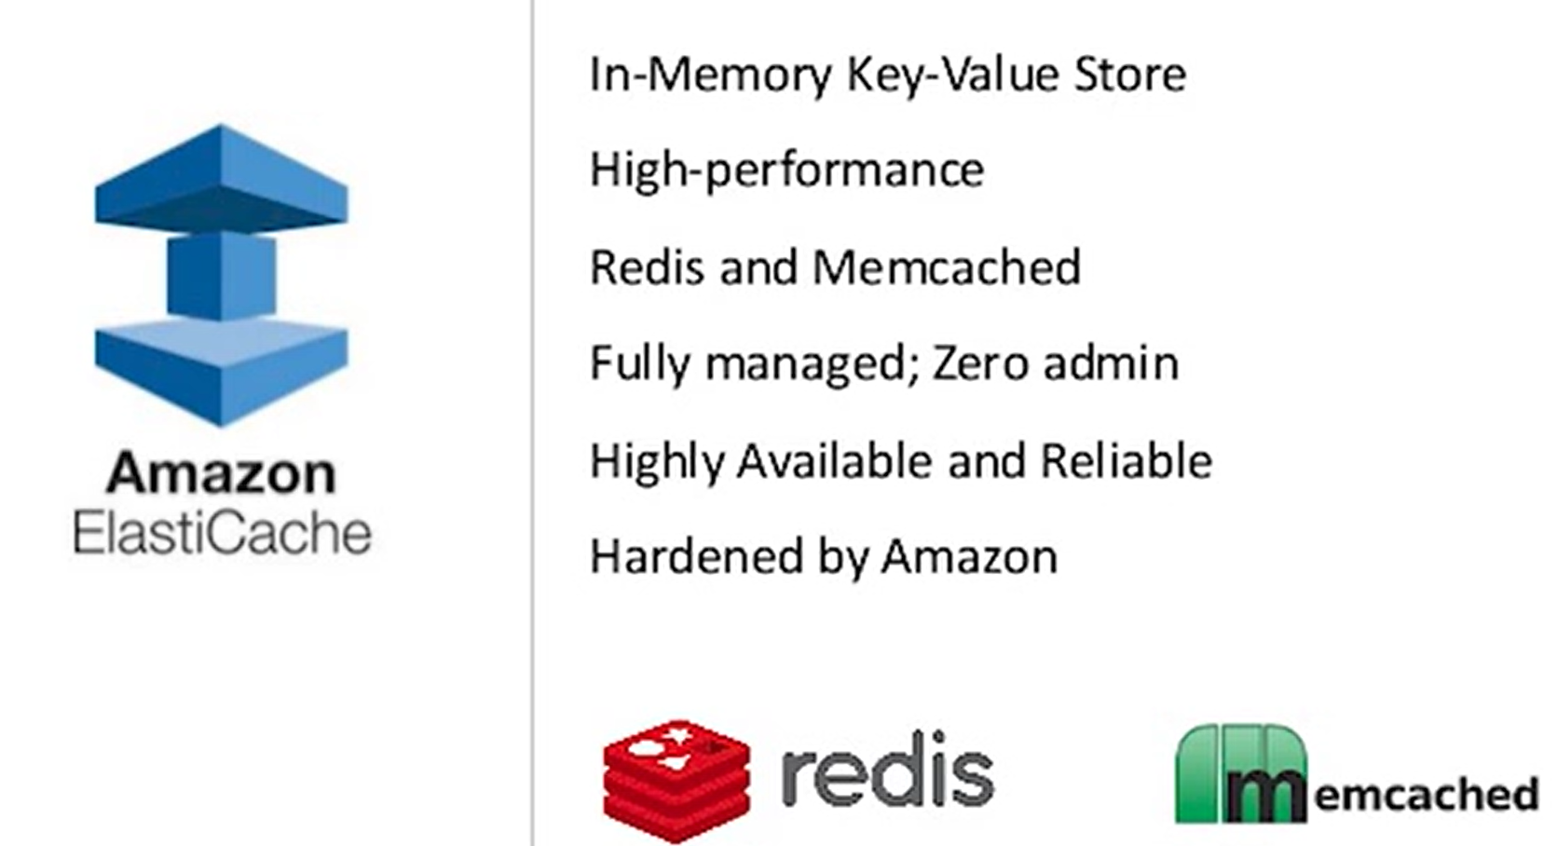

**Two popular Cache Engine🡪Redis and Memcached**

**Amazon Redshift🡪 Datawarehouse-OLTP (on Transaction database)**